Books (main page): All will be VIDEOS

Please don’t copy and paste; the Design style needs to change

Categories

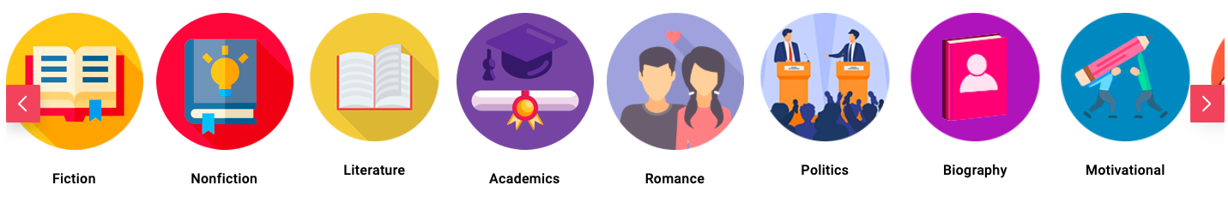

New Release:

  

Most popular:

  

Upcoming launches:

  

SHOW YOUR VIDEO HERE

DETAILED PAGE: After clicking on the video

Same as the blog details page

Below the video: Title, categories, journal name, authors name, DOI/HSN, year, keywords/meta tag, organization name, country, URL link, and a short description will be written (same as YouTube video website descriptions)

The download of PDF/PPT

SHOW YOUR VIDEO HERE

People also viewed/similar vedios/suggested vedio:

  